**DevOps Introduction:**

The DevOps is the combination of two words, one is **Development** and other is **Operations**. It is a culture to promote the development and operation process collectively.

**What is DevOps?**

The DevOps is a combination of two words, one is software Development, and second is Operations. This allows a single team to handle the entire application lifecycle, from development to **testing, deployment**, and **operations**. DevOps helps you to reduce the disconnection between software developers, quality assurance (QA) engineers, and system administrators.

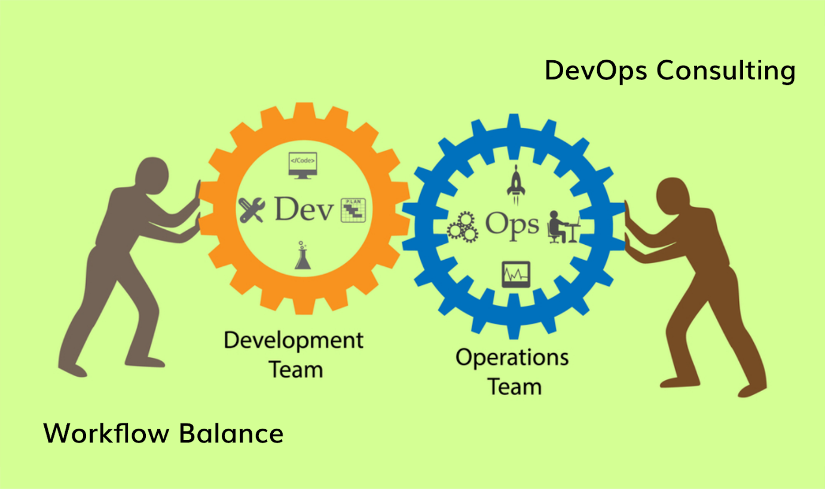

DevOps helps to increase organization speed to deliver applications and services. It also allows organizations to serve their customers better and compete more strongly in the market.

DevOps can also be defined as a sequence of development and IT operations with better communication and collaboration.

DevOps has become one of the most valuable business disciplines for enterprises or organizations. With the help of DevOps, **quality**, and **speed** of the application delivery has improved to a great extent.

**Why DevOps?**

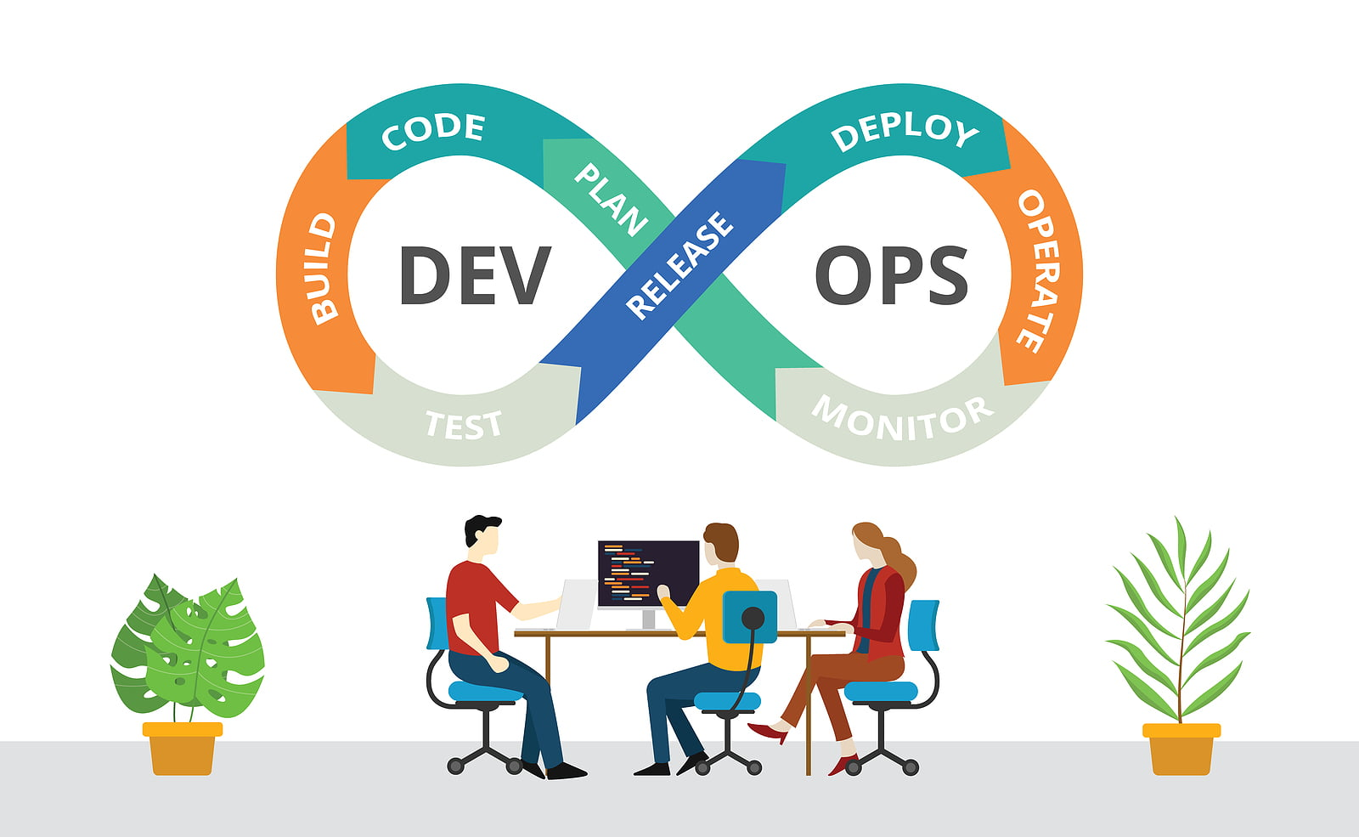

Before going further, we need to understand why we need the DevOps over the other methods.

* The operation and development team worked in complete isolation.
* After the design-build, the testing and deployment are performed respectively. That's why they consumed more time than actual build cycles.
* Without the use of DevOps, the team members are spending a large amount of time on designing, testing, and deploying instead of building the project.
* Manual code deployment leads to human errors in production.
* Coding and operation teams have their separate timelines and are not in synch, causing further delays.

## What is SDLC?

SDLC is a process followed for a software project, within a software organization. It consists of a detailed plan describing how to develop, maintain, replace and alter or enhance specific software. The life cycle defines a methodology for improving the quality of software and the overall development process. The following figure is a graphical representation of the various stages of a typical SDLC. 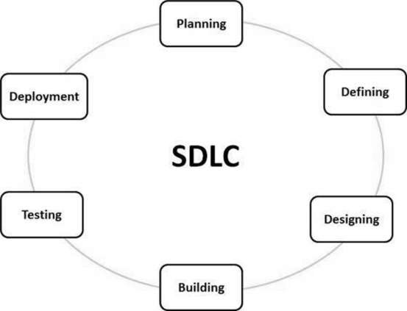

There are various software development life cycle models defined and designed which are followed during the software development process. These models are also referred as Software Development Process Models". Each process model follows a Series of steps unique to its type to ensure success in the process of software development.

Following are the most important and popular SDLC models followed in the industry −

* Waterfall Model
* Iterative Model

## What is Agile Methodology?

An agile methodology is an iterative approach to software development. Each iteration of agile methodology takes a short time interval of 1 to 4 weeks. The agile development process is aligned to deliver the changing business requirement. It distributes the software with faster and fewer changes.

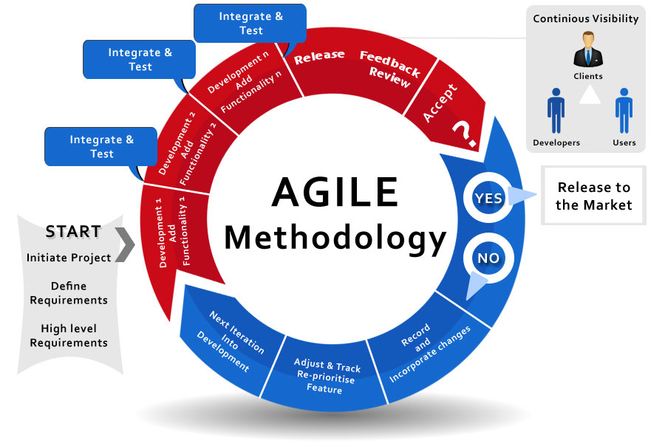

An Agile methodology is not a specific set of ceremonies or specific development techniques. Rather, it is a group of methodologies that demonstrate a commitment to tight feedback cycles and continuous improvement. An Agile team works in iterations to deliver the customer requirement, and each iteration takes 10 to 15 days. However, the original Agile Manifesto didn't set the time period of two-week iterations or an ideal team size.

Each user requirement is a planned based and their backlog prioritization and size. The team decides, how much scope they have and how many hours available with each team to perform their planed task.

The Agile involves continuous iteration of development and testing in the **SDLC** process. Both development and testing activities are concurrent, unlike the waterfall model. This software development method emphasizes on incremental, iterative, and evolutionary development.

It breaks the product into small pieces and integrates them for final testing. It can be implemented in many ways, such as **Jira , Scrum** and **Kanban** etc.

The Agile software development focus on the four core values, such as:

* Working software over comprehensive documentation.
* Responded to change over following a plan.
* Customer collaboration over contract negotiation.
* Individual and team interaction over the process and tools.

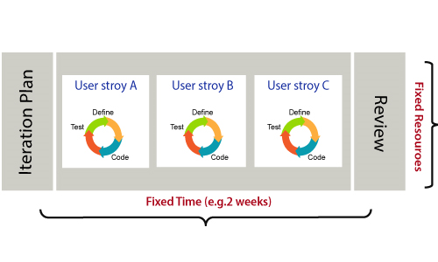

DevOps Advantages

Here are some advantages that DevOps can have for business, such as:

### **Advantages**

* DevOps is an excellent approach for quick development and deployment of applications.
* It responds faster to the market changes to improve business growth.
* DevOps escalate business profit by decreasing software delivery time and transportation costs.
* DevOps clears the descriptive process, which gives clarity on product development and delivery.
* It improves customer experience and satisfaction.
* DevOps simplifies collaboration and places all tools in the cloud for customers to access.
* DevOps means collective responsibility, which leads to better team engagement and productivity.

# **DevOps Tools**

Here are some most popular DevOps tools with brief explanation shown in the below image, such as:

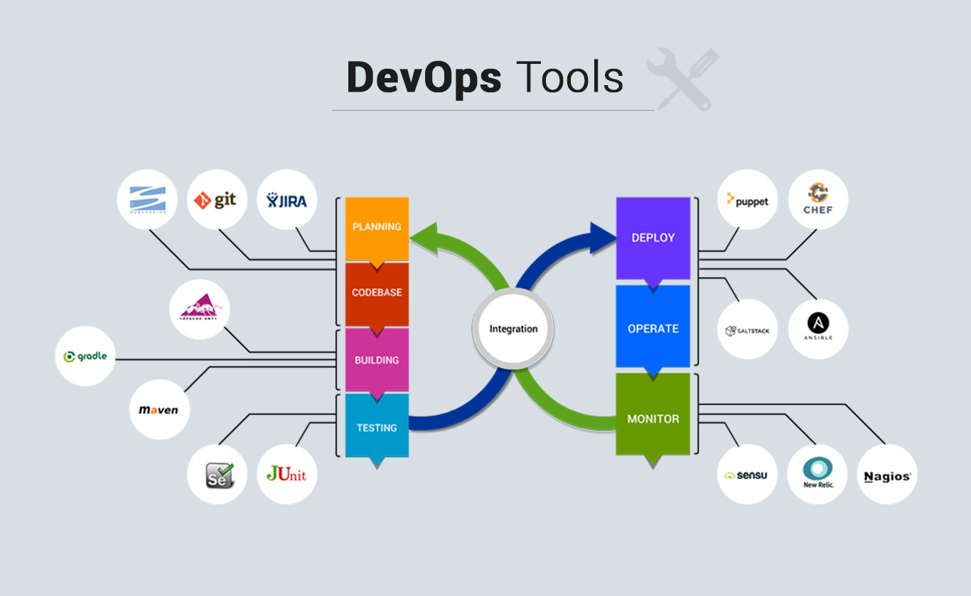

Any one scripting language:

Scripting: **Shell, Python**

Monitoring Tools**: Prometheus, Grafana**

Build:

Build Compilers: **Maven, Gradle**

Tools: **Jenkins, CircleCI, Github Actions**

Deploy: **Jenkins, Ansible**

Planning: **Jira, Kanban**

Codebase: **Git, BitBucket**

Testing Tool: **Postman**